2015 Winterport Dragway Schedule

March 8 Driver’s Meeting 10:00AM
Jordan's Snack Bar, Ellsworth
April 26
Opening Day
Darling’s Ford Gamblers Points Series Race # 1
May 3
First Day of Points
Regular Bracket Program
Junior Dragster Points Race #1

May 10
Old Geezers Race
Happy Mother’s Day
Ladies Day
Regular Bracket Program

May 16 Saturday
Camp-out Weekend # 1
Darling’s Ford Gamblers Points Series Race # 2
Gassah Guys Nostalgia Reunion

May 17
Regular Bracket Program

May 24

Regular Bracket Program

May 30
Robin Reynolds Memorial Street Nights #1
Racing 4:00PM – Dark

May 31
Regular Bracket Program
Junior Dragster Points Race #2

June 6
Coastal Mustang Cruise Show & Track Day

June 7
Mike Johnson Memorial Mopar Day
Small Block Chevy Race (Rain Date July 5)
Sponsored by SBC Racing & Boss-A-Nova Racing
Regular Bracket Program

Winterport Residents Day

June 14
Pontiac Day
Regular Bracket Program

June 19 Friday (Rain Date July 3)
Gassah Guys Time Trials 4:00PM – Dark

June 20 Saturday (Rain Date July 4)
Jimmy Jordan Memorial Car Show, Drag Race & Swap Meet
Camp-out Weekend # 2
Darling’s Ford Gamblers Points Series Race # 3
Gassah Guys Nostalgia Reunion
June 21
Happy Fathers Day
Truck Day
Regular Bracket Program
Quick 8 Door Car Race (Pro Tree) (Rain Date July 5)

June 28

CLOSED ~ Exile Weekend
July 5 (Rain Date for Small Block Chevy Race)
Regular Bracket Program
Pro Day (Bonus Purse for Pro)
Rain date for Quick 8 Door Car Race June 21
Junior Dragster Points Race #3
July 12
Super Pro Day (Bonus Purse for Super Pro)
Ford Day
Regular Bracket Program
July 17 Fri. Friday (Rain Date July 24)
Gassah Guys Time Trials 4:00PM - Dark

July 18 Saturday (Rain Date July 25)
Camp-out Weekend # 3
Darling’s Ford Gamblers Points Series Race # 4
Gassah Guys Nostalgia Reunion
Swap Meet
Rolling Burn-Out Contest

July 19 (Rain Date July 26)
Richard “Tater” Gray Memorial Diesel Day
Sponsored by Diesel Fuel Systems
Regular Bracket Program
July 24 (Scheduled only as Rain Date for July 17)
July 25 Sat. (Scheduled only as Rain Date for July 18)

July 26 (Rain Date for July 19)
Street Day (Bonus Purse for Street)
Regular Bracket Program
Junior Dragster Points Race #4

August 2 (Rain Date August 30)
Jim & Kathy Hyde Memorial Race
Regular Bracket Program
Race Nostalgia Day (Vehicles 25 or more years old)
Camaro Vs Mustang Challenge
August 7 Friday (Rain Date August 14)
Gassah Guys Time Trials 4:00PM - Dark
August 8 Saturday (Rain Date August 15)
Gassah Guys ONLY Event
NO GAMBLERS RACE
Gassah Guys Nostalgia Reunion
Gassah Guys Mid-Season Championships
Camp-out Weekend #4
Swap Meet

August 9 (Rain Date August 16)

(Rain Date for August 2)
Jeff Paluga Memorial King of the Street Race
5th Annual Big $$$ Bikes, Sleds, ATVs Meet
Regular Bracket Program
Aug 14 Fri. (Scheduled only as Rain Date for Aug 7)
Aug. 15 Sat. (Scheduled only as Rain Date for Aug 8)
August 16 (Rain Date for August 9)
Regular Bracket Program

August 22
Robin Reynolds Memorial Street Nights #2
Racing 4:00PM – Dark

August 23
Regular Bracket Program
Chevy Day
Junior Dragster Points Race #5

August 30 (Rain Date for Aug 2)
Regular Bracket Program
Canadian Day
Quick 8 Door Car Race (Pro Tree) (Rain Date Sept 6)
September 5 Tyler’s Big Rig Race & Show
(Rain Date September 19)

September 6
Salute To America
AMC/Jeep/Rambler Day
Wheel Stand Contest
Regular Bracket Program
Rain date for Quick 8 Door Car Race Aug 30
September 12 Saturday
Camp-out Weekend #5
Darling’s Ford Gamblers Points Series Race #5
Gassah Guys Nostalgia Reunion
Swap Meet
September 13
Regular Bracket Program

September 19 (Scheduled only as Rain Date for Sept 5)

September 20
Big Block Chevy Race (Rain Date Sept 27)
Regular Bracket Program
Track Record Day

September 27
Rain Date for Big Block Chevy Race
Regular Bracket Program
Junior Dragster Points Race #6
October 3
Robin Reynolds Memorial Street Nights #3
Racing Noon – Dark
October 4
Regular Bracket Program
Racer Appreciation Day
October 10 Sat. (Rain Date Oct 17)
Fall Car Show, Drag Race & Swap Meet
Camp-out Weekend #6
Gassah Guys Nostalgia Reunion
Darling’s Ford Gamblers Points Series Race # 6
October 11
Regular Bracket Program
Last Day of Points (No Rain Date)
October 17 Sat. (Scheduled only as Rain Date for Oct 10)
October 18 (Scheduled only as Rain Date for Oct 11)
Non-Points Gamblers Race
November 14
Awards Banquet

Schedule Subject to Change

Admission ~ Sunday
Racers & Spectators ~ $12
Tech Card ~ $10
Regular Sunday Race Entry Fee ~ $15
Junior (Age 13-15) ~ $5,
Children 12 & Under ~ FREE
Regular Sunday Buy-Backs ~ $15
(1st or 2nd Round, One only, NOT BOTH)

Admission ~ Fridays & Saturdays
2 Day Pass ~ $20 (Sold only on Fridays & Saturdays)
3 Day Pass ~ $30 (Sold only on Fridays)
Racers & Spectators ~ $12
Tech Card ~ $10
Junior (age 13-15) ~ $5,
Children 12 & Under ~ FREE
Buy-Backs Saturdays ~ $10 per round
(1st & 2nd rounds, Either or Both)
Car Show Entry Fee ~ $5 (Driver & Car Show Entry)
$5 Admission for 1st Passenger in Each Car Show Entry

List of Car Show Classes
Best of Pre 49
Best of the 50's
Best of the 60's
Best of the 70's
Best of the 80s & UP
Mustang
Muscle Car
Mopar
Truck Pre 73
Truck 73 & UP
Street Rod
Corvette
Camaro
Special Interest
Motorcycle, Sled & ATV
Import/Sport Compact
PEOPLE'S CHOICE AWARD
BEST OF SHOW

Schedule Subject to Change
Track Information

Racing Format Sundays

Gates Open: 8 AM
Tech Opens: 8 AM

Time Trials: 8:30 AM, Eliminations ~ 12:30 PM

Racing Format
For Fridays ~
(June 19th, July 17th, & Aug. 7th)
Gates Open ~ 12 Noon, Racing Tech Opens ~ 4 PM

Racing Time Trials ~ 4PM - Dark

Racing Format Saturdays ~ Car Shows
(June 20th & October 10th)
Gates Open ~ 8 AM, Racing Tech Opens ~ 8 AM

Car Show Registration ~ 8AM - 11AM

Car Show Judging ~ 9 AM - 12 PM
Car Show Awards ~ 2 PM

Gassah Guys Time Trials ~ 9AM - 12 PM,

Gassah Guys Eliminations ~ 1:00 PM,

Darling’s Ford Gamblers Race Time Trials ~ 12:00 PM,

Darling’s Ford Gamblers Race Eliminations ~ 2:30 PM,

Racing Format For Saturdays ~
(May 16th, July 18th, & Sept. 12th)
Gates Open ~ 8 AM, Racing Tech Opens ~ 8 AM

Gassah Guys Time Trials ~ 9AM - 12 PM,

Gassah Guys Eliminations ~ 1:00 PM,

Darling’s Ford Gamblers Race Time Trials ~ 12:00 PM,

Darling’s Ford Gamblers Race Eliminations ~ 2:30 PM,

Racing Format For Saturday Aug 8th
Gassah Guys ONLY Event
NO GAMBLERS RACE
Gates Open ~ 8 AM, Racing Tech Opens ~ 8 AM

Time Trials ~ 9AM -12 PM, Eliminations ~ 12:30 PM

Points Classes
Super Pro ~ Box
Pro ~ No Box
Motorcycles & Snowmobiles
Pro Street ~ Street Legal Gamblers Race
Darling’s Ford Gamblers Points Series
Junior Dragster

Non-Points Classes
Street Trophy ~ FREE ENTRY with Tech Card
Import/Sport Compact ~ 4 & 6 Cylinder Only
ATV/Quad, Teen Racing
Hot Rod Lawn Mower

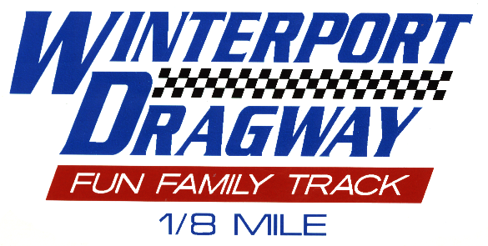
Track Phone ~ Race Days only ~ 223-3998

2015 Schedule

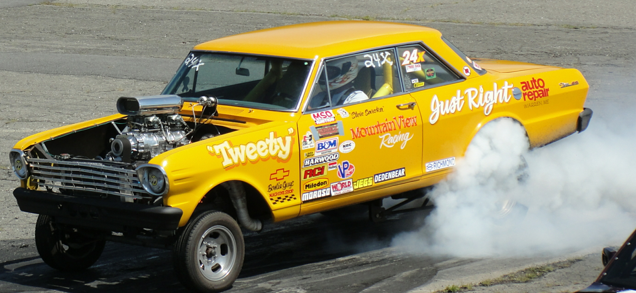

Published by
Winterport Dragway Association
In Cooperation With

Mountain View Landscaping
&
Mountain View Drag Racing
2217 Eastern Road
Warren ME 04864
phone: 207- 273-2957

Winterport Dragway Contact Information
Rich Kopper ~ Track Manager ~ 299-3528
Jim Watson, President ~ (Home)963-2667 (cell)460-6565
Vaughan Stevens ~ Gassah Guys ~ 215-5663
Track Phone ~ Race Days only ~ 223-3998
Track Phone will be manned 7:00-9:00 AM on questionable weather days.
Web site ~ www.winterportdragway.com

Food concessions by Deb’s Variety Snack Bar

Fenced Playground for the Kids

VP Racing Fuels at the track provided by

Urquhart Machine & Fuel Sales

